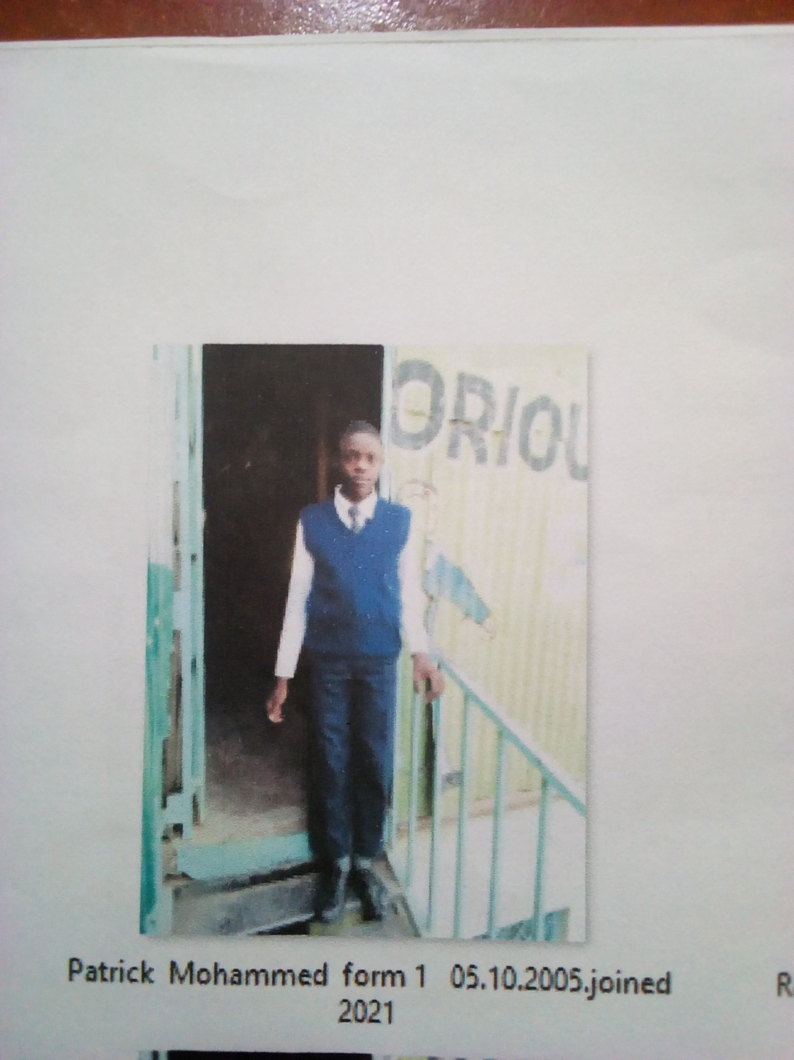

PATRICK MOHAMMED FORM 1 BORN 2005 JOINED 2021
Patrick 16 years was enrolled in our school when she was 16 years old. Patrick is a need boy staying with disabled parents who can hardly afford a meal. Came to school seeking help in pathetic condition. Looking at his condition the school empathized with him to access education. She was allowed in school; glorious is a place for his bright future. He is promising to help others in the same state of life.
Thanks to the Director Mr. Boniface Mangeti who allowed Patrick in school. I am now learning in glorious at least I have a place I call home praying that one day God will help our school have good classes, toilets and enough learning materials. Thank you Michell and Brad for your support have really helped many in Mukuru

